**Bilkent University**

Department of Computer Engineering

**CS 319 Project**

*Best Trade*

Final Report

Group Members

* Ezgi Çakır
* İbrahim Berker Kırdök
* İlhami Özer
* Irmak Tural
* Berk Türk

Contents

1. Implementation 3

2. Status Report 3

3. User Guide 4

3.1 Introduction 4

3.2 Installation 4

3.3 Using the system 4

# 1. Implementation

We start the implementation by considering our design and layers. It is organized into three subsystems. First we started to implement the classes of User Interface subsystem and the classes of Trade Subsystem. Then we started to implement the class of Database Management subsystem. The graphical user interface is not challenging, but arranging panels and transition between them by buttons and arranging their visibilities take time. Also the classes of Trade Subsystem is not challenging, because the our design of hierarchy is not complicated. The implementation of Database Management Subsystem is challenging for us. Because SQL and the database is a new notion for us. When the user pushes data to database, the data is not refreshed and we had connection problems. We did not make major changes on our design while implementation.

# 2. Status Report

* User Interface Subsystem– 60%
* Trade – 60%
* Database Management –20%

The functions and the interaction between our classes and database will be investigated more deeply.

# 3. User Guide

3.1 Introduction

BestTrade is a system that user can view, add items (books, furnitures, notes) to sell. Users have accounts to log in the system.

3.2 Installation

1. System Requirements

* It requires Java Runtime Environment

3.3 Using the System

The Login Screen is displayed when the application starts first.

1) Login Screen

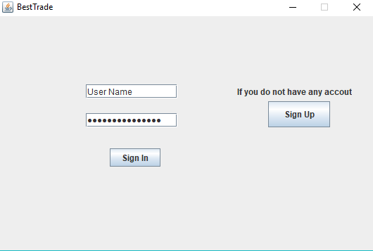

**Figure 1 – Login Screen**

In this screen, users that had an account can write their unique username and password to enter the screen. The ones who has not an account can click on the “Sign Up” button to create an account.

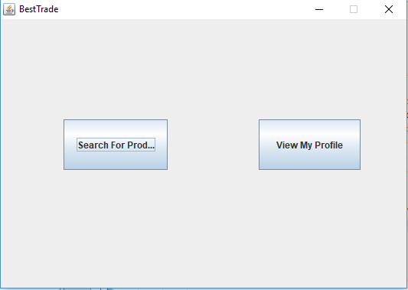2) Trade Screen

**Figure 2 – Trade Screen**

This screen displays itself if the sign in process is successful. Users can either search for items that other user sells in system or check their profiles.

3) Sign Up Screen

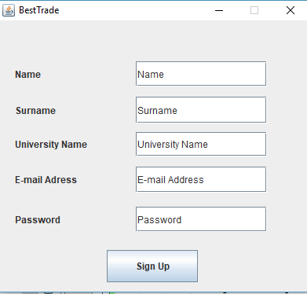

**Figure 3 – Sign Up Screen**

In this screen, users have to enter the information that is needed to sign up to the system. However, the username and e-mail address must be unique in order to successfully signing up to the system.

4) Activation Code Screen

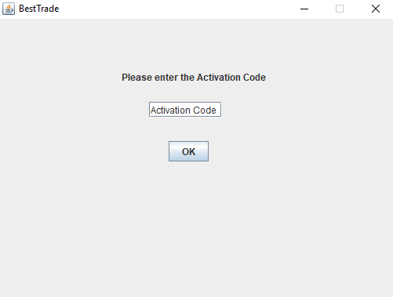

**Figure 4 – Activation Code Screen**

After a successful sign up period, this screen automatically shows up and asks for a activation code that the system sends to the given e-mail address.

5) Add Item Screen

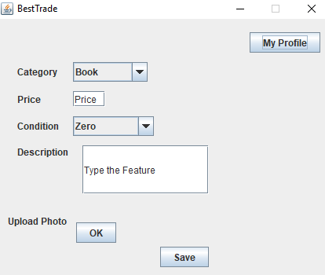

**Figure 5 –Add Item Screen**

This screen enables users to add an item based on the attributes they give to the system. After clicking save, the attributes are saved.

6) View Item Screen

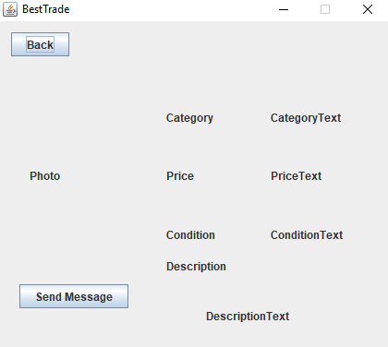

**Figure 6 –View Item Screen**

In view item screen, users can check any item that they see. The item has a photo, a category, a price and condition whether it is second hand or not.

7) Send Message Screen

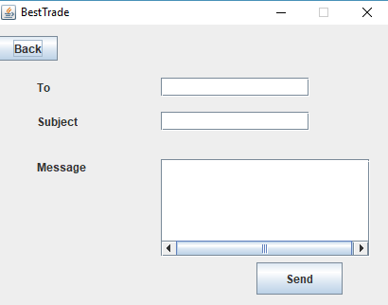

**Figure 7 –Send Message Screen**

In send message screen, the users can send messages to a user that sells items. To send a message, the user has to write the other user’s name, what the subject is, and some message to clarify the subject.

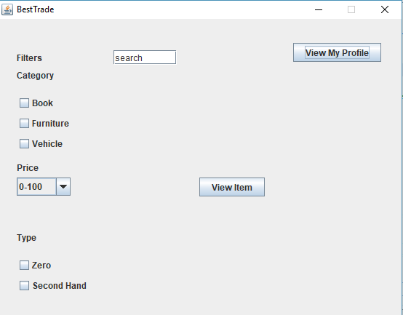8)Search Item Screen

**Figure 8 –Search Item Screen**

In this screen, users can search for any item they wanted via the filters on left. The items which corrects those filters is presented on the middle of screen.

9)My Profile Screen

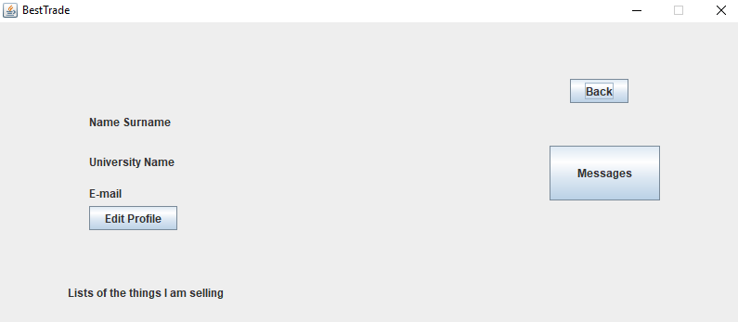

**Figure 9 –My Profile Screen**

This screen contains information about the user. In this screen, any user can edit their existing profiles, delete or edit their item information, take a look at the items the user is selling at the moment, or look at their inbox via “Messages” button.

Edit Profile

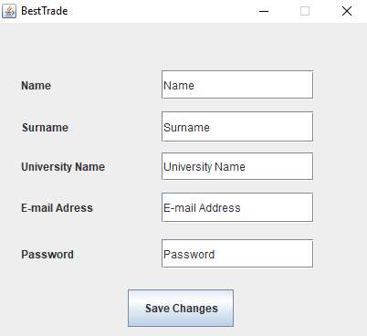

**Figure 10 –Edit Profile Screen**

This screen has similarities with the sign up screen, however in this screen, users can change their profile information.